Project Report
Quiz Application For Conducting Quiz And Evaluating Marks

Siva Prasanth S
192110404
Computer Science Engineering

Contents

Introduction
About the Application
Objective
Features Added
Working – Flow Chart Representation
Conclusion

Introduction:
The "QuizApp" is an Android application designed to provide users with an engaging and interactive quiz experience. This application allows users to test their knowledge on a variety of topics by answering a series of multiple-choice questions. The application offers a user-friendly interface and features that make it easy and enjoyable for users to participate in quizzes. In this report, we will provide an overview of the application, its features, and how it functions.

About the Application:
The "QuizApp" is a mobile application built for Android devices. It offers an entertaining and educational way to challenge and enhance one's knowledge on a wide range of subjects. Here are some key aspects of the application:

User-Friendly Interface: The application features a clean and intuitive user interface, making it accessible to a wide range of users, including those new to mobile apps.

Quiz Questions: The core functionality of the app revolves around a collection of quiz questions. These questions cover various topics and subjects, making the application suitable for different interests.

Multiple-Choice Questions: Each quiz question is presented as a multiple-choice question, with three answer options (A, B, C).

Scoring System: Users can track their performance as they progress through the quiz. The application keeps a score based on correct answers.

Quiz Termination: Users have the option to terminate the quiz at any time. Upon termination, the application provides the user's final score.

Quiz Restart: After completing or terminating a quiz, users can restart the quiz, giving them the opportunity to improve their score or try a different set of questions.

Working:

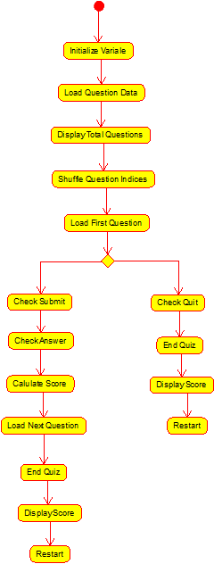

Objective:

The primary objective of the "QuizApp" is to provide an engaging and educational platform for Android users to participate in quizzes. The application is designed to:

Test Knowledge: Enable users to assess their knowledge on various subjects through a series of multiple-choice questions.

Educational Entertainment: Offer an enjoyable and interactive learning experience by presenting quizzes on a wide range of topics, encouraging users to expand their knowledge while having fun.

Features Added:
The "QuizApp" comes with several features that enhance the user experience and provide a comprehensive quiz environment:

Randomized Questions: The application randomizes the order of questions, ensuring that each quiz session is unique.

Color Feedback: To make the user interface more engaging, the application provides color feedback when users select an answer. The selected answer is highlighted in magenta, and incorrect answers are cleared, enhancing user interaction.

Quiz Completion Dialog: When a user completes the quiz or decides to terminate it, a dialog box displays the user's score and offers the option to restart the quiz. This feature encourages users to continue improving their knowledge.

Shuffling Questions: The application shuffles the questions to ensure a varied experience for users in each quiz session.

Total Questions Counter: The application displays the total number of questions in the quiz, helping users keep track of their progress.

Application Title: The title "Quiz Application" is displayed at the top, giving users a clear indication of the application's purpose.

Restart Functionality: Users can restart the quiz at any point, providing a continuous learning experience.

Conclusion:
Overall, the "QuizApp" aims to make the process of learning and testing one's knowledge fun and interactive. The application is well-suited for educational purposes, self-assessment, and simply having an enjoyable time while engaging with quiz questions on a wide range of topics. Users can restart the quiz, challenge themselves, and improve their scores as they continue to learn.

